**R42 AI Lecture 1**

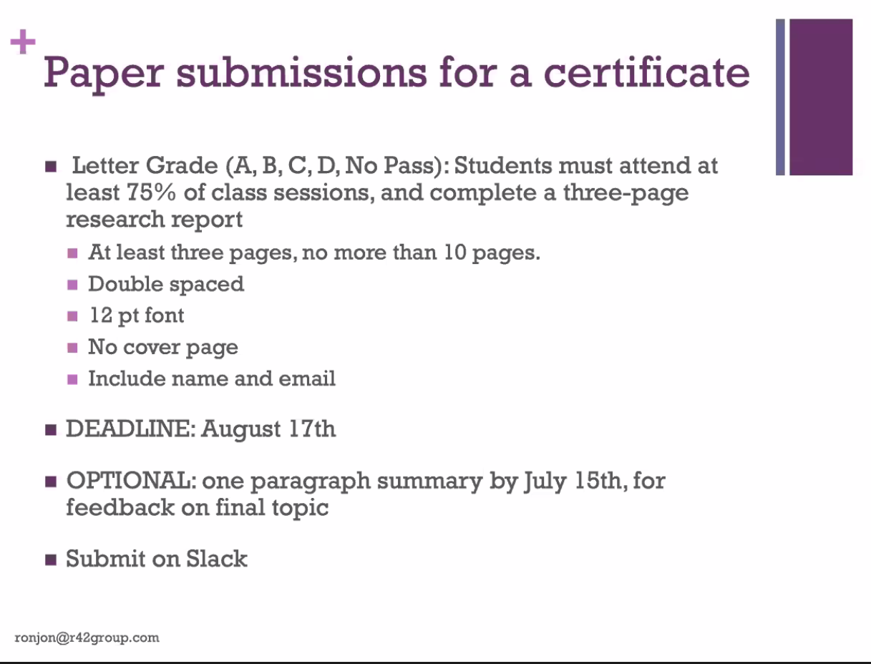

14th august is summary paragraph deadline?

4 days after final lecture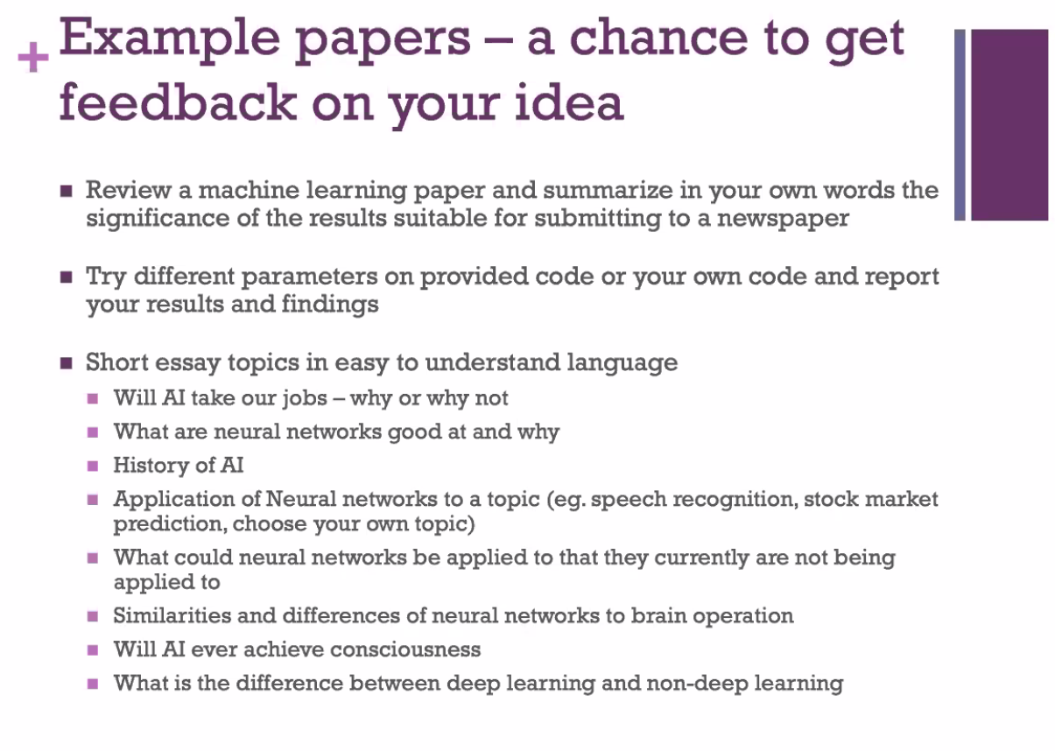

**Recommended Reading**

Make your own neural network - Tariq Rashid

Deep learning with python - François Chollet

using genetic algorithms to train neural networks

-done before, although some things done before may work now because of increases in processing power

**Terminology**

GOFAI: rules-based systems and symbolic processing (decision trees)

-has issues with imperfect handwriting, people not actually following grammar rules when speaking (so how do you decode that with just rules?) etc.

Machine Learning: learning from data (logistic regression, SVMs, random forests, hidden markov models, neural networks-recurrent, adversarial, convolutional, deep learning, autoencoder)

AI: field providing human-like intelligent functions

Weak AI, Narrow AI

Generalised AI, AGI, strong AI: human performance intelligence, perform any task a human can, equivalent intelligence to a human

**Platforms**

Tensorflow

CNTK

Pytorch

CUDA

DIGITS

Keras

H2O

**Supervised Learning**

Learning from labelled data

Go through labelled data, extract features, create model from features (if input has **X** features, output is most likely to be y)

**Unsupervised Learning**

Clustering

Vector/matrix quantisation

Find correlations/similarities/clusters in unlabelled data

**Toddlers**

Start unsupervised-don’t have language, pure association

Move to supervised later -still just association? Is it the same thing at core, just abstracted to a higher level, associating with word which link to ideas, rather than directly to ideas?

**Iterative Learning**

Trial and error

Make smaller changes if error is smaller

Size of changes adjustable with learning rate

**Activation Function**

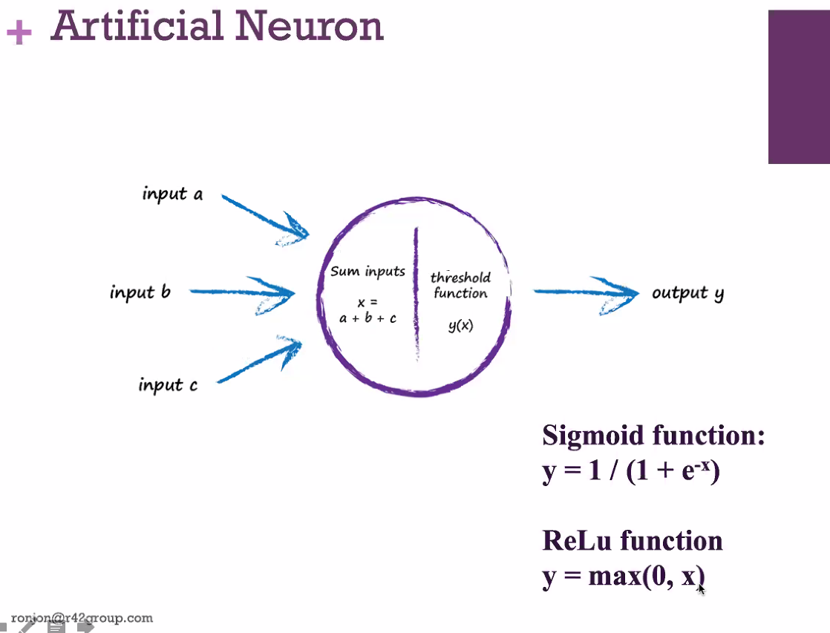

ReLu (rectified linear unit): if it’s more than 0, activate, otherwise don’t. Mostly ruperseded sigmoid function

**Data Wrangling**

-clean up data (missing values, errors etc.)

-formatting data

-makes it easier to process data and to explain model

**Gradient Descent**

Back propagation: see error, adjust previous node and pass error back